WORKSHEET

TOPIC-Sound and vibrations
CLASS-VIII MARKS: 10m
TIME: 15Minutes

- Answer the following : (1Mx4=4M)

- What is sound?
__________________________________________________________________
- Mention the basic cause of sound?
__________________________________________________________________
- Name the sense organ which helps you to hear.( Eye, Nose, Ear, Skin) {S.A.}
__________________________________________________________________
- Write the types of energy produced when :
- We clap our hands: ______________________
- We rub our hands : ______________________

- Read the passage and answer the following: (½+½+1=2M)

Krishna used to be very excited to attend the morning school assembly as the choir used to sing the prayer songs very melodiously which was soothing. He used to wonder as how the instruments played could make different types of sounds accompanying the choir.
He was awestruck to see the noisy students falling into proper lines and doing the prayer as soon as the choir started the prayer songs. He asked his teacher about it.
The teacher explained that Music has great significance. Further Krishna expressed that he wanted to know about the sound of instruments played. His teacher told him about each instrument played in the choir and the sound produced by it.

- Why did the teacher say that Music has great significance in life?( Open ended)
________________________________________________________________________

- How do you think the instruments produced sounds?
________________________________________________________________________

- Mention any two values by demonstrated Krishna.
________________________________________________________________________

III.Mention the Vibrating part for the given instruments in the table. (½Mx6=3M)

S.NO. | MUSICAL INSTRUMENT | VIBRATING PART PRODUCING SOUND
1 | 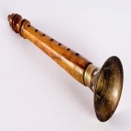  Shehanai
2. | 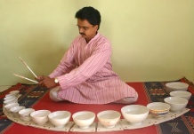  Jal Tarang
3. | 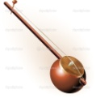  Ektara
4. | Harmonium  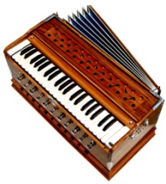
5. | 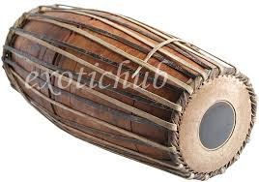  Mridangam
6. | 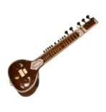  Veena

- Answer the following: (HOTS) (1X1M=1M)

- Mention the difference between the type of sound produced when
- A Veena is played
- A rusted gate is opened or closed.
_____________________________________________________________________________________ _____________________________________________________________________________________
__________________________________________________________________________________________________________________________________________________________________________

