CHAPTER-1
BRICKS , BEADS AND BONES THE HARAPPAN CIVILISATION
ONE MARK QUESTIONS
- HARAPPA IS LOCATED ON THE BANKS OF WHICH RIVER ?
- THE ‘ GREAT BATH’ WAS FOUND IN WHICH TOWN OF THE INDUS VALLEY CIVILISATION ?
- WHICH TOWN IN INDUS VALLEY CIVILISATION HAD NO CITADEL ?
- WHAT WAS THE MAIN FEATURE OF THE HARAPPAN CIVILISATION ?
- WHERE WERE LARGE GRANARIES FOUND ?
- WHICH TWO STRATEGIES ARE ADOPTED BY THE ARCHAEOLOGISTS TO IDENTIFY SOCIAL DIFFERENCES AMONG THE HARAPPANS ?
- WHY IS HARAPPAN SCRIPT CONSIDERED AS AN ENIGMATIC SCRIPT ?
- WHO WAS CUNNINGHAM ?
- MENTION ANY TWO ITEMS FOUND IN THE GRAVE OF THE HARAPPANS.
- WRITE ANY ONE OTHER NAME OF HARAPPAN CIVILISATION.
- WHICH SITE OF HARAPPAN CIVILISATION BELONG TO HARYANA ?
- FROM WHERE DID HARAPPANS GET GOLD ?
- WHICH SITE WAS THE SOURCE OF COPPER FOR HARAPPANS ?
- WRITE ANY TWO REASONS RESPONSIBLE FOR DECLINE OF HARAPPAN CIVILISATION.
- WHICH WERE THE TWO MOST IMPORTANT CITIES OF THE HARAPPAN CIVILISATION ?
- WHAT IS FAIENCE ?
- WRITE THE NAMES OF ANY TWO IMPORTANT STRUCTURES FOUND IN THE CITADEL OF MOHENJODARO.
- WRITE ANY ONE FEATURE OF BRICKS USED IN THE HARAPPAN CIVILISATION.
- IN WHICH SETTLEMENTS OF HARAPPAN CULTURE SPECIALISED DRILLS HAVE BEEN FOUND .
- WHAT ARE SHAMANS ?
- WHO WAS JOHN MARSHALL ?
- WHAT WAS A MOUND ?
Multiple choice questions:
- - At which of the following sites traces of canals have been found at Harappan sites ?
- Punjab (b) Haryana (c) Sindh (d) Shortughai in Afghanistan
- Which of the following artefacts is not classified as utilitarian ?
- Querns (b) pottery (c) needles (d) little pots of faience or silica
- In which of the following sites the miniature pots of faience are not found at the Harappan sites.
- Mohenjodaro (b) Harappan (c) Kalibengan (d) None of the above
- What is the area of Mohenjodaro ?
- 100 hectares (b) 125 hectares (c) 150 Hectares (d) none of the above
- When did R.E.M Wheeler take over as Director-General of ASI ?
- 1942 (b) 1943 (c) 1943 (d) 1945
- Match the following
- Archaeo- Botanists - i) identify of the sender
- Archaeo- Zoologists ii) long distance communication
- Seals iii) Animal bones
- Sealing iv) specialists in ancient plant remain
- Match the following
- Models of plough - i) Chanhudaro
- Ploughed field - ii) Harappan sites
- Gold jewellery - iii) Cholistan and Banawali
- Craft production iv) Chanhudaro
- Match the following
- Cunningham - i) story of Indian Archaeology
- Daya Ram Sahni - ii) Found seals at Mohenjodaro
- Rakhal Das Bannerjee - iii) Archaeologist- discovered seals at Harappa
- S.N.Roy - iv) First director general of ASI
Fill in the Blanks
- The dietary practices of Harappan people have been reconstructed by the Archaeologist from finds of _________and ________.
- Red colour of carnelian was obtained by _________the yellowish raw material and beads at various stages of production.
- Nageshwar and Balakot are near the __________. These were specialized centres for making ______including bangles, ladles and inlay.
- The most important indicator of a place , which specializes in craft production is __________.
- The lower denominations of weights were________(1,2,4,8,16,32,etc upto 12800) while the higher denominations followed the _______.
- A large building found at ____was labeled as a palace by archaeologists but no spectacular finds were associated with it .
- A stone statue was labeled and continues to be known as the _______.

Identify the image:
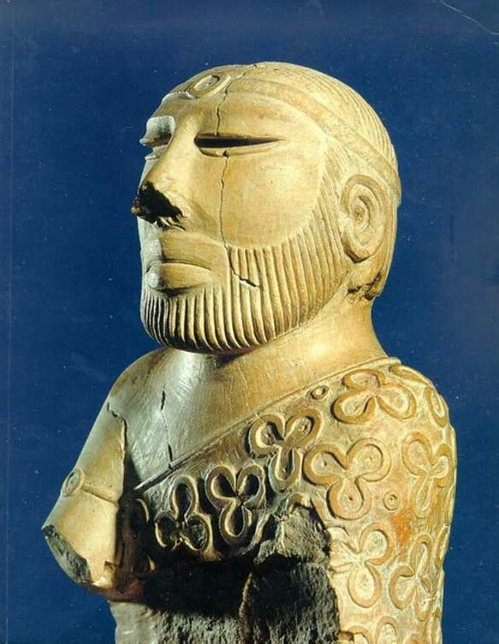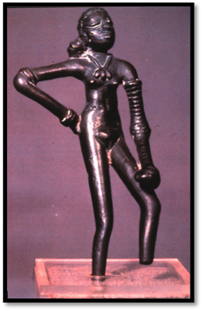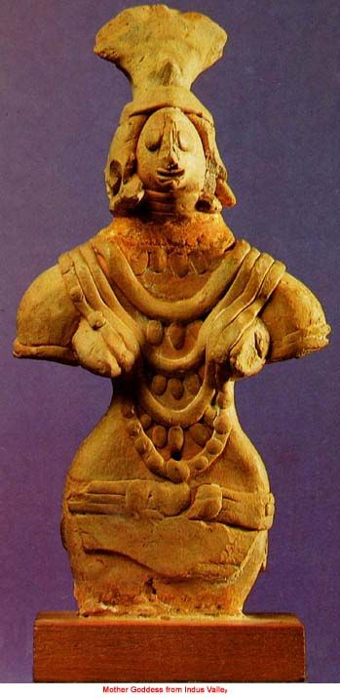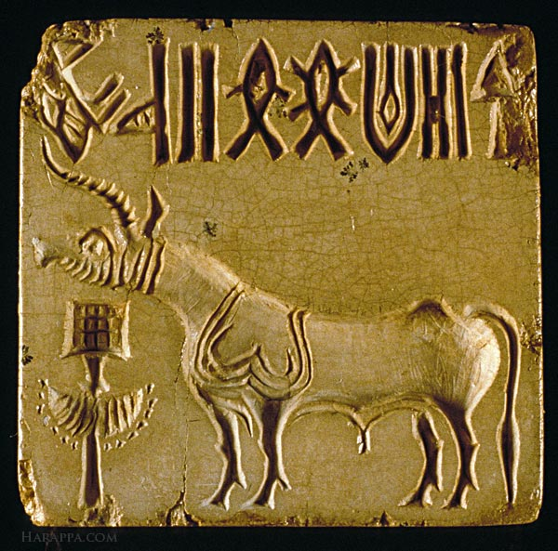
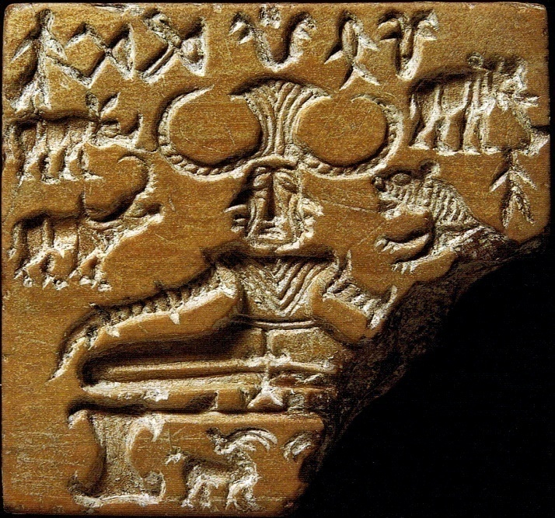

CHAPTER-2
KINGS, FARMERS AND TOWNS- EARLY STATES AND ECONOMIES
ONE MARK QUESTIONS:
- WHAT ARE NORTHERN BLACK POLISHED WARE ?
- WHO WERE DHAMMA MAHAMATTAS ?
- WHY IS SIXTH CENTURY BCE OFTEN REGARDED AS A MAJOR TURNING POINT IN INDIAN HISTORY ?
- WHO COMPOSED THE PRAYAG PRASHASTI IN PRAISE OF SAMUNDRAGUPTA ?
- WHAT WERE THE GUILDS OF THE MERCHANTS AND CRAFTSMEN CALLED ?
- WHAT IS JAMES PRINSEP’S CONTRIBUTION IN THE DEVELOPMENT OF THE INDIAN EPIGRAPHY ?
- WHO ISSUED THE FIRST COINS BEARING THE NAMES OF RULERS ?
- ASHOKA IS MENTIONED BY WHICH TITLES IN INSCRIPTIONS.
- WHAT WERE MAHAJANAPADAS ?
- WHO WAS HARISENSA?
- WHAT IS MANUSMRITI ?
- WHAT ARE INSCRIPTIONS ?
- STUDY OF INSCRIPTIONS IS KNOWN AS………
- STUDY OF COINS IS KNOWN AS…………
- WHO DECIPHERED BRAHMI AND KHAROSHTI SCRIPTS ?
- HOW MANY MAHAJANAPADAS WERE THERE ?
- WHO FOUNDED THE MAURYAN EMPIRE ?
- SANGAM IS A LITERATURE OF …………. LANGUAGE.
- WHAT WAS THE EARLY CAPITAL OF MAGADHA ?
- WHICH MAHAJANAPADA EMERGED AS THE STRONGEST ONE ?
- WHO WAS THE CHIEF ?
- WHAT ARE VOTIVE OR DONATORY INSCRIPTIONS ?
- WHO ISSUED THE FIRST GOLD COINS ?
- NAME THE FIRST KING WHO PATRONAGED OR ADOPTED BUDDHISM.
- NAME THE AUTHOR OF ARTHASHASTRA AND INDICA.
- What is Numismatics
- What is an Oligarchy ?
- What is paleography?
Select the correct option out of the four possible optins given after the statement of the question:
- Which one of the following statement is not correct about the sixth century BCE ?
- It is associated with early states (c) There was growing use of iron
- There was development of coinage (d) large empires were established
- Which of the following rulers founded the Mauryan Empire in 321 BCE ?
- Ashoka (b) Chandragupta Vikramaditya (c) Chandragupta Maurya (d) Bindusar
- Which of the following was not a provincial centre during the period of Chandragupta Maurya ?
- Taxila (b) Tosali (c) Ujjayini (d) Indraprastha
- Prabhavati Gupta was daughter of which of the following rulers in the early Indian history.
- Chandragupta Maurya (b) Ashoka (c) Chandragupta II (d) Chandragupta I
- Match the following
- Mahajanapadas i) Vajji
- Ganas ii) Magadha
- Sangha iii) Oligarchies
- Most powerful Mahajanapadas iv) Kings
- Match the following
- Ashoka i) Allahabad pillar inscriptions
- Megasthenes ii) Arthashastra
- Kautilya iii) Greek ambassador
- Harishena iv) Kalinga/ inscriptions
Fill in the blanks:
Fill in the blanks
- Initially, Rajagaha was the capital of ________. The old name means _______.
- ______mentions a committee with six subcommittees for coordinating military activity.
- Special officers, known as the ________were appointed to spread the message of dhamma.
- Many Kushana rulers adopted the title________or son of god, possibly inspired by _________rulers who called themselves sons of heaven.
- ______inscriptions record gifts made to religious institutions.
- The first gold coins were issued c. first century by the ________.
- Meaning of Erythraean of the Periplus Sea_____________.
- Meaning of:
Gahapati, Vellalar, Uzhavar, Adimai
- Identify the image:
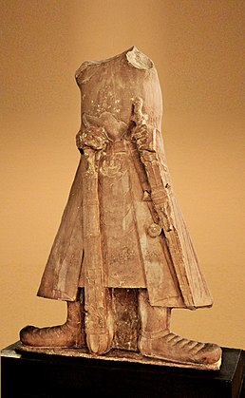
CHAPTER-3
KINSHIP, CASTE AND CLASS – EARLY SOCIETIES
ONE MARK QUESTIONS:
- HOW MANY VERSES ARE THERE IN MAHABHARATA ?
- WHO WON THE BATTLE OF MAHABHARATA ?
- ACCORDING TO SHASTRAS , ONLY ……………COULD RULE THE COUNTRY.
- NAME THE RULER WHO FOLLOWED ENDOGAMY.
- NAME THE COMMON WIFE OF PANDAVAS.
- DURYODHANA AND HIS BROTHERS WERE KNOWN AS …
- DISTINGUISH BETWEEN PATRILINY AND MATRILINY.
- WHAT IS POLYANDRY TYPE OF MARRIAGE ?
- WHAT IS ENDOGAMY TYPE OF MARRIAGE ?
- WRITE ANY ONE IMPORTANT RULE ABOUT THE GOTRA SYSTEM.
- WHAT DO WE CALLED THE COMMUNITY THAT WERE NOT GIVEN IMPORTANCE IN THE VARNA SYSTEM.
- MYTHOLOGICALLY WHO IS CONSIDERED AS THE AUTHOR OF MAHABHARATA….
- NAME THE FIFTH VEDA.
- WHAT IS STRIDHANA ?
- WHAT IS VAMSHA ?
- WHAT IS KULA ?
- WRITE ANY ONE OCCUPATION OF KSHATRIYA.
- IN WHICH BOOK DUTIES HAVE BEEN LAID DOWN FOR CHANDALS.
- WRITE ONE WAY EVOLOVED BY BRAHAMANS TO ENFORCE THE NORMS OF VARNA ORDER.
- IN WHICH TYPE OF MARRIAGE DOES A WOMEN HAVE SEVERAL HUSBANDS.
- SHAKAS WHO WERE FROM CENTRAL ASIA WERE REGARDED BY THE BRAHAMANS AS..
- ORIGINAL STORY OF MAHABHARATA WAS COMPOSED BY…
- WHO PREPARED THE CRITICAL EDITION OF MAHABHARATA ?
Select the correct option out of the four possible options given after the statement of the question:
- How much period of time was taken for composing the present form of Mahabharata epic in its present form ?
- Over a period of 500 years (c) over a period of 1000 years
- Over a period of 1200 years (d) over a period of 1500 years
- Which one of the following statements regarding method of working under the project for preparing the critical edition of Mahabharata is not correct ?
- Compare verses from each manuscript (c) Selection of verses common to most versions
- Publishing of versions in several volumes running into over 13000 pages.
d)None of the above

- Which of the following strategies for ideal occupations of varnas was not adopted by the Brahamans in its support ?
- Varna order was of divine origin
- Advised kings to ensure that these norms were followed within their kingdoms.
- To persuade people that their status was determined by their birth
- None of the above
- Match the following
- Kauravas i) pandu
- Pandavas ii) eldest son of pandu
- Duryodhana iii) Dhritarasthra
- Yudhisthira iv) eldest son of Dhritarashtra
- Match the following
- Brahamans i) to engage in agriculture and trade
- Kshatriyas ii) to engage in warfare and protect people
- Vaishyas iii) to serve the three higher varnas
- Shudras iv) to study and teach the Vedas
- Match the following
- Brahamana i) feet
- Kshatriyas ii) arms
- Vaishyas iii) thighs
- Shudra iv) Mouth
Fill in the blanks:
- One of the most ambitious project began in ________under the leadership of noted Indian Sanskritist_______for preparing a critical edition of the Mahabharata.
- Each gotra was named after a _______ and all those who belonged to the same gotra were regarded as his _______.
- In due course, Hidimba gave birth to a rakshahsa boy named _________. Then the mother and son left the Pandavas.
- Some activities were regarded as particularly’ polluting’’ . These included handling corpses and dead animals. Those who performed such tasks, designated as _________were placed at the very bottom of the hierarchy.
- The text of Mahabharata is described as an itihasa within early Sanskrit tradition. The literal meaning of the term is ______ which is why it is generally translated as _____________.

CHAPTER-4
THINKERS, BELIEFS AND BUILDINGS-CULTURAL DEVELOPMENT
ONE MARK QUESTIONS:
- WHERE DID BUDDHA ATTAIN ENLIGHTENMENT ?
- WHAT WAS THE NAME OF THE GANA TO WHICH BUDDHA BELONGED TO ?
- WHAT IS THE MEANING OF ‘ THREE BASKETS’ ?
- THE SANGHAS WAS AN ASSOCIATION OF WHOM ?
- ACCORDING TO WHICH BUDDHIST TEXT ASHOKA DISTRIBUTED PORTIONS OF THE BUDDHA’S RELICS TO EVERY IMPORTANT TOWN AND ORDERED THE CONSTRUCTION OF STUPAS OVER THEM.
- WHAT DOES THE SYMBOL OF ‘ EMPTY SEAT’ SYMBOLISED ?
- WHAT IS THE MOST IMPORTANT COMMON TEACHING IN BUDDHISM AND JAINISM ?
- WHO PROVIDED MONEY FOR THE PRESERVATION OF THE SANCHI STUPA ?
- WHAT WAS THE BALCONY LIKE STRUCTURE IN A STUPA CALLED ?
- WHERE IS SANCHI STUPA SITUATED ?
- WHAT WERE CHAITYAS ?
- WHAT IS HAGIOGRAPHY ?
- WHERE IS AMARAVATI STUPA SITUATED ?
- 24 GREAT TEACHERS OF JAINISM ARE KNOWN AS….
- …..IS THE BIRTH PLACE OF GAUTAMA BUDDHA.
- NEW TRADITION OF BUDDHISM WAS CALLED AS .
- MAKE A LIST OF WORLD FAMOUS THINKERS OF MID- FIRST MILLENIUM BCE.
- NAME THE TWO ELABORATE SACRIFICES . WHO USED TO PERFORM THEM ?
- IN WHICH COUNTRIES ,OUT OF SUBCONTINENT, DID THE TEACHINGS OF BUDDHA SPREAD ?
- WHICH THREE LIFE STORIES OR SCENE BROUGHT A SEA OF CHANGE IN THE LIFE OF BUDDHA ?
- NAME ANY FOUR PLACES ASSOCIATED WITH THE LIFE OF BUDDHA .
- WHAT ARE STUPAS ?
- WHICH TWO RELIGIONS EMERGED AGAINST THE HINDU SOCIETY IN SIXTH CENTURY BCE ?
- WHAT IS THE MEANING OF UPANISHADS ?
- WHICH PHILOSOPHY BECOME POPULAR JAINISM OR BUDDHISM AND WHY ?
- WHAT IS ELLIOT MARBLES ?
Select the correct option out of the four possible options given after the statement of the question:
- Which one of the following statements are true about the thinkers (Socrates, Buddha, Mahavira etc.) of the mid- first millennium BCE in the world ?
- They tried to understand the mysteries of existence and the relationship between human beings and the cosmic order
- New kingdoms and cities were developing
- Social and economic life was changing in a variety of ways in the Ganga valley.
- All the above
- By 1850s some of the slabs from Amaravati had begun to be taken to different places. Which of the following places were not included among them ?
- Asiatic society of Bengal at Calcutta
- India office in Madras
- London to adorn the gardens of British administrators
- Indian Museum, Delhi
- Which of the following was the literal meaning of Mahayana ?
- Small vehicle (b) great vehicle (c) middle vehicle (d) lesser vehicle
- How many avatars were recognised within the Vaishnavism ?
- 8 (b) 9 (c) 10 (d) 11
- Match the following
- Zarthustra I) Greece
- Kong Zi ii) India
- Socrates and Plato iii) China
- Mahavira/ Gautam iv) India
- Match the following
- Mahavira i) China, Korea, Japan
- Buddha ii) Buddha’s disciple
- Ananda iii) Buddha’s foster mother
- Mahapajapati Gotami iv) 24th tirthankara
Fill in the blanks
- Rigveda consists of hymns in praise of a variety of deities,especially ___________,_________and____________.
- The most important sacrifices performed by the ancient rulers were__________and ________.
- Many of the teachers including Mahavira and _________ questioned the authority of the ____.
- When Buddhism spread to East Asia , pilgrims such as _________and ___________travelled all the way from China to India in search of texts.
- In 1854________the commissioner of Guntur visited Amaravati and collected several sculpture panels and took them away to __________.
- The early temple was a small square room, called the _______________with a single doorway for the worshippers to enter and offer worship to the image.
- The tall structure, in a temple, built over the central shrine came to be known as _________
- Buddha’s foster mother__________wa the first women to be ordained as a _____________
- The internal functioning of the Sangha was based on the tradition’s of _________and _________where consensus was arrived at through discussions.
- Identify the image:
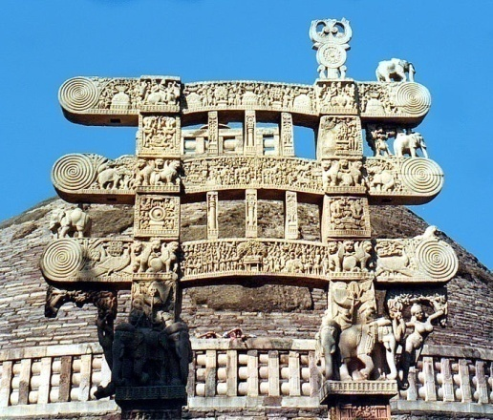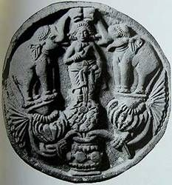
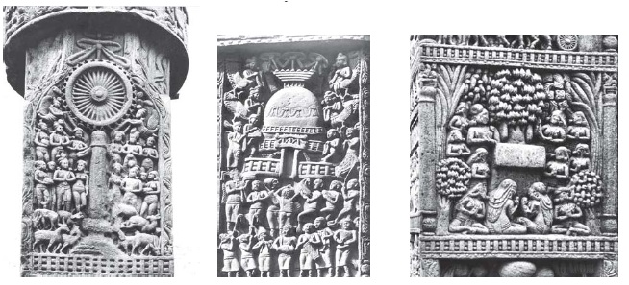
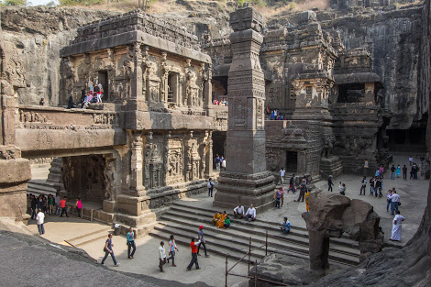

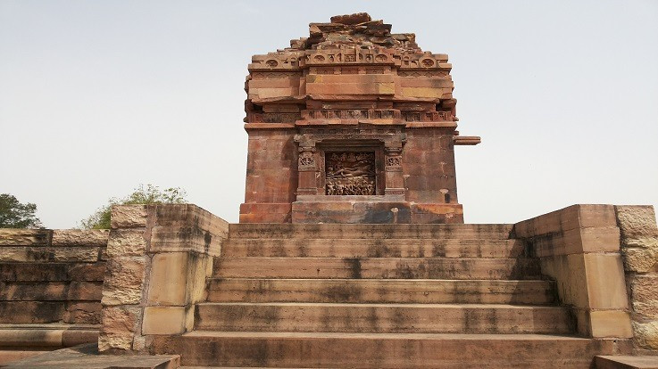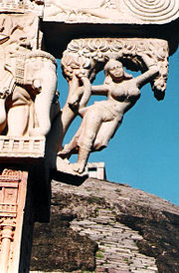
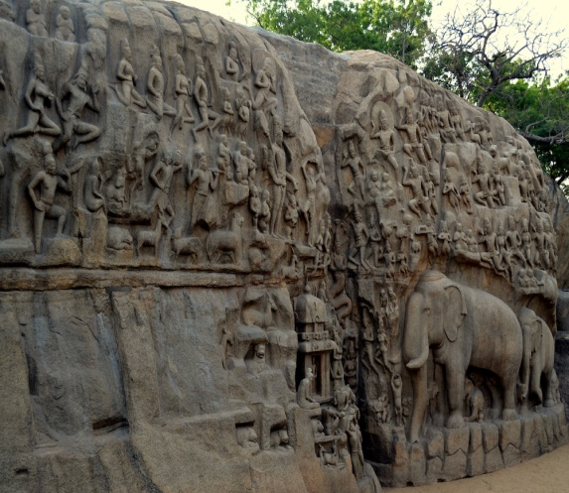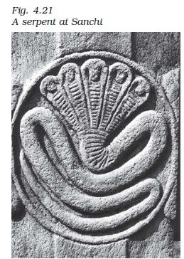
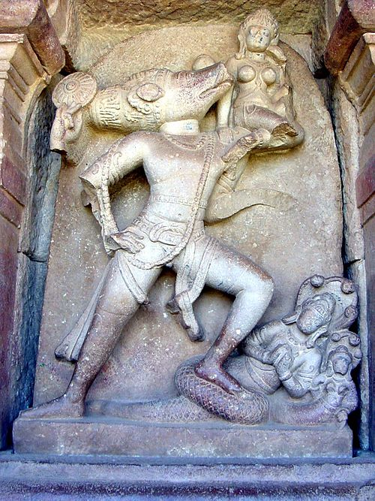

CHAPTER-5
THROUGH THE EYES OF TRAVELLERS- PERCEPTIONS OF SOCIETY
ONE MARK QUESTIONS:
- NAME THE FRENCH TRAVELLERS CAME TO THE SUBCONTINENT DURING 17TH CENTURY ?
- WHICH TRAVELLER BELONGED TO MOROCCO ?
- WHO WROTE KITAB-UL-HIND ?
- ISLAMIC LAW IS KNOWN AS…….
- IBN BATTUTA REMAINED IN INDIA FOR …………YEARS.
- ACCORDING TO IBN BATTUTA WHICH CITY WAS THE LARGEST DELHI OR DAULTABAD.
- WHO WROTE THE BOOK’ TRAVELLS IN THE MUGHAL EMPIRE’ ?
- NAME THE AUTHOR OF RIHLA.
- WHICH METHOD WAS ADOPTED BY AL-BIRUNI FOR WRITING THE BOOK ?
- ACCORDING TO IBN- BATTUTA UNIQUE POASTAL SYSTEM OF INDIA WAS DIVIDED IN TWO PARTS NAME THEM.
- MENTION ANY ONE BARRIER FELT BY AL- BIRUNI IN INDIA.
- WHICH PORTUGUESE WRITER PROVIDED A DETAILED ACCOUNT OF TRADE AND SOCIETY IN SOUTH INDIA ?
- WHO GAVE US THE MOST IMPORTANT DESCRIPTION OF VIJAYANAGARA IN THE 15TH CENTURY ?
- WHO GAVE THE THEORY “ THE CROWN OWNERSHIP OF LAND” ?
- WHICH TWO PHILOSOPHERS FURTHER SUPPORTED THE CROWN OWNERSHIP OF LAND ?
- MENTION ANY ONE CHARACTERISTIC OF THE CITIES IN THE INDIAN SUBCONTINENT AS DESCRIBED BY IBN BATTUTA.
- TO WHICH COUNTRY DID AL BIRUNI COMPARED THE INDIAN CATE SYSTEM.
Select the correct option out of the four possible options given after the statement of the question:
- Name two things which have special mention in Ibn Battuta’s description of India .
- Rice and Coconut (b) Wheat and paan (c) Coconut and Paan (d) Paan and rice
- Which of the following travelers gave the most important descriptions of the city of Vijayanagara in the fifteenth century ?
- Ibn battuta (b) Abdur Razzaq Samarqandi (c) Al-Biruni (d) Abul Fazl
- Which of the following places were visited by Ibn Battuta during his travels ?
- Malabar coast, Bengal, Assam, Delhi (c) Maldives
- SriLanka (d) All
- Al-Beruni depended almost exclusively on the works of Brahamanas and cited passages from which of the following works ?
- The Vedas (b) The Puranas (c) The Bhagwat Gita, The Manusmriti (d) Works of Patanjali
- Which one of the following foreign travelers, asserted” There is no idle class in India” ?
- Ibn Battuta (b) Francois Bernier (c) Al-Biruni (d) Abdur Razzaq
- Who had described land revenue as ‘ renumerations of sovereignty
- Abul Fazl (b) Todar Mal (c) Man Singh (d) Ibn Battuta
- Match the following
- Al Biruni i) India
- Ibn Battuta ii) France
- Francois Bernier iii) Morocco
- Abul Fazl iv) Uzbekistan
- Match the following
- Kitab –ul-Hind i) Ibn Battuta
- Rihla ii) Bernier
- Travels in the Mughal Empire iii) Abul Fazl
- Ain-i-Akbari iv) Al- Beruni
Fill in the blanks
- Ibn Battuta was born in ___into one of the most respectable and educated families known for their expertise in________.
- The account of Ibn Battuta is often compared with that of ___________who visited China(and also India) from his home base in ________in the late thirteenth century.
- Most bazaars had a_________and a _____________and in some of them at least ,spaces were marked for public performances by_________________,____________and _______.
- Among the best known of the Portuguese writers is ________who wrote a detailed account of trade and society in south India.
- The postal system in India was so efficient that the news reports of spies from Sindh to Delhi could reach the Sultan within ________days.

CHAPTER-6
BHAKTI- SUFI TRADITIONS
ONE MARK QUESTIONS:
- WHO ARE ULAMA ?
- WHAT ARE THE DEVOTEES OF VISHNU CALLED ?
- WHAT IS THE LITERAL MEANING OF THE TERM ‘ SILSILA’ ?
- WHO COMPOSED THE PREM –AKHYAN PADMAVAT ?
- WHO LED A NEW RELIGIOUS MOVEMENT IN KARNATAKA ? WHAT WERE HIS FOLLOWERS KNOWN AS ?
- GIVE THE MEANING OF ZIMMA .
- EXPLAIN THE TERM ZIYARAT.
- MENTION THE TWO EARLIEST BHAKTI MOVEMENTS OF TAMILNADU.
- NAME THE TWO WOMEN POET SAINTS OF TAMILNADU. WHOM DID THEY WORSHIP ?
- MENTION ANY TWO IDEAS OF BRAHAMANICAL SYSTEM CHALLENGED BY THE LINGAYATS .
- IN WHICH TWO BROAD CATEGORIES HAD THE EARLIEST BHAKTI TRADITIONS BEEN CLASSIFIED.
- WHERE IS KHWAJA MUINUDDIN CHISTI DARGAH IS LOCATED ?
- NAME ANY TWO NIRGUNA BHAKTI SAINT.
- NAME ANY TWO SAGUNA BHAKTI SAINTS.
- NON- MUSLIM HAD TO PAY A RELIGIOUS TAX CALLED .
- NAME ANY ONE SUFI SAINT OF CHISHTI SILSILA.
- WHO IS THE FOUNDER OF LINGAYAT MOVEMENT ?
- NAME ANY ONE TEMPLE BUILT BY CHOLA RULERS IN SUPPORT OF BHAKTI MOVEMENT.
- NAME THE MAJOR ANTHOLOGY COMPILED BY THE ALVARS WHICH IS ALSO DESCRIBED AS TAMIL VEDA.
- WHAT DO YOU MEAN BY THE TERM ‘ FIVE BASIC PILLARS OF ISLAM’ ?
- WRITE ANY ONE SIMILARITY BETWEEN THE BHAKTI AND SUFI MOVEMENT.
- WHAT IS TAWAWWUFF ?
- WHO COINED THE TERM ‘ MUSLIMS’ FOR THE ISLAMIC COMMUNITY.
- WHAT IS MEANT BY LANGAR SYSTEM ?
- NAME ONE COMPOSITION OF KABIR WHICH CONVEY A SENSE OF KABIR’S MYSTICAL EXPERIENCES.
Select the correct option out of the four possible options given after the statement of the questions:
- Which of the following statements is not true about the Lingayats ?
- The ligayats challenged the idea of caste and the pollution attributed to certain groups by Brahamanas
- They questioned the theory of rebirth
- They also encouraged certain practices disapproved in the Dharmashastras, such as post-puberty marriage
- They disapproved the remarriage of widows
- When they see a serpent carved in stone they pour milk on it, If a real serpent comes they say ‘ Kill Kill’. Who among the following saint said above vachana.
- Kabir (b) Guru Nanak (c) Basavanna (d) Tulsidas
- In which of the following centuries, Delhi sultanate was established ?
- 11th century (b) 12th century (c) 13th century (d) 14th century
- Under which practice women after marriage remained in their natal home with their children and the husbands could come to stay with them ?
- Joint family system (b) patriarchy (c) patriliny (d) matrilocal residences
- Who were not included in the category of the Zimi ?
- Jews (b) Hindus (c) Christians (d) Muslims
- Name the Mughal ruler, who had abolished Jaziya.
- Babur (b) Akbar (c) Humayun (d) Jahangir
- Match the following
- Arab Muslim Traders -i) Tamil Nadu
- Alvars and Nayanars -ii) North India
- Virshaiva -iii) Malabar Coast (Kerala )
- Naths Jogis -iv) Karnataka
- Match the following
- Prayers five times a day -i) Zakat
- Giving alms -ii) Sawn
- Fasting during the month of Ramzan –iii) Hajj
- Performing pilgrimage to Mecca - iv) Namaz/Salat
- Match the following
- Kabir -i) Nankana Sahib
- Baba Guru Nanak –ii) Successor of Guru Nanak
- Mardana -iii) Saint poet- ultimate reality
- Angad -iv) Played the rabab
Fill in the blanks
- One of the most striking examples of the process of integration of cults is evident at_____________Orissa, where the principal deity was identified by the twelfth century,as (literally, the lord of the world) a form of ________.
- The terms great and little traditions were coined by a sociologist named___________in the twentieth century to describe the cultural practices of peasant societies.
- Nirguna bhakti was worship of _________________form of god.
- Alvars were devotees of ___________- and Nayanars were devotees to_________.
- The major compositions by the Alvars was ______________. It has been considered as ____________in the literary circles.
- The two women devotees of Alvars and Nayanars were ___________and___________.
- Lingayats worshipped Shiva in his manifestation as a ________________
- Arab Muslim traders who settled along the Malabar Coast (Kerala) adopted the local language________. They also adopted local customs such as _____________matrilocal residence.
- Identify the image.

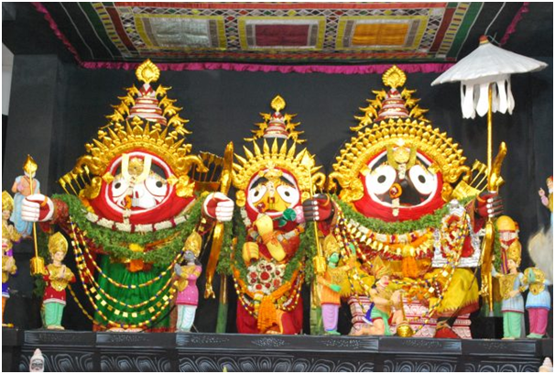

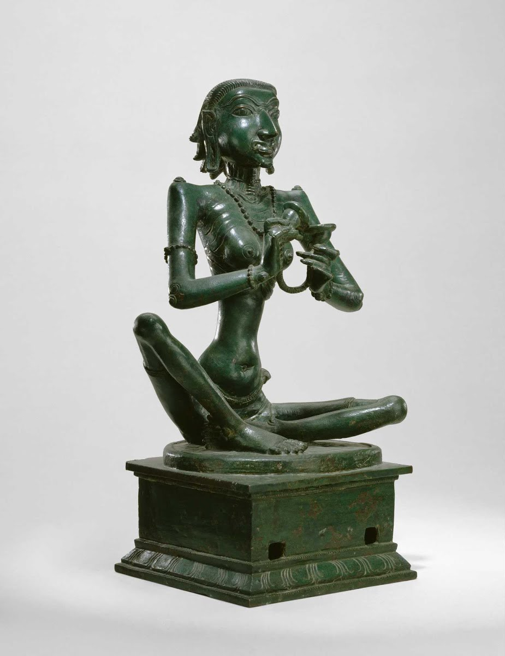

CHAPTER-7
AN IMPERIAL CAPITAL- VIJAYANAGARA
ONE MARK QUESTIONS:
- OTHER NAME OF VIJAYANAGARA CITY WAS ….
- WHEN WAS VIJAYANAGARA KINGDOM ESTABLISHED ?
- WHO ESTABLISHED VIJAYANAGARA KINGDOM ?
- THE FIIRST DYNASTY RULED OVER VIJAYANAGARA EMPIRE WAS …
- LOCAL GODDESS OF VIJAYANAGAR ARE….
- WHICH RIVER WAS THE MAJOR SOURCE OF WATER FOR VIJAYANAGARA…
- WHEN WAS HAMPI DECLARED AS OF PLACE OF NATIONAL IMPORTANCE ?
- WHO WAS THE MOST FAMOUS RULER OF VIJAYANAGARA ?
- WHO WERE AMARA- NAYAKAS ?
- NAME ANY TWO SPECIAL RITUALS ASSOCIATED WITH MAHANAVMI DIBBA .
- NAME THE BATTLE RESPONSIBLE FOR THE DECLINE OF VIJAYANAGARA EMPIRE.
- WHEN AND WHO DISCOVERED THE RUINS OF HAMPI ?
- WHICH RULER COMPOSED THE WORK, AMUKTAMALYADA ?
- WHICH PERSIAN AMBASSADOR VISITED THE VIJAYANAGARA EMPIRE ?
- THE BATTLE OF TALIKOTA BETWEEN VIJAYANAGARA AND THE DECCAN SULTANS TOOK PLACE IN WHICH YEAR.
- GIVE ANY ONE STRIKING FEATURE ABOUT THE LOCATION OF VIJAYANAGARA EMPIRE.
- WHICH PART OF VIJAYANAGARA IS TERMED AS ROYAL CENTRE ?
- WHICH TEMPLE ARCHITECTURE WAS USED IN THE CONSTRUCION OF VIJAYANAGARA TEMPLES ?
- NAME ANY ONE TEMPLE SITUATED IN ROYAL CENTRE ?
- TO WHICH HINDU DEITY THE VIRUPAKSHA TEMPLE IS BEEN ASSOCIATED ?
Select the correct option out of the four possible options given after the statement of the question:
- Which of the following rulers is credited with building some fine temples and adding impressive gopurams to many south Indian temples ?
- Rama Raya (b) Bukka (c) Krishna Deva Raya (d) Harihara
- In the battle of Talikota, Which of the following Sultanates did not take part in defeating the army of Vijayanagara ?
- Delhi (b) Bijapur (c) Ahmadnagar (d) Golconda
- Which one of the following raya of Vijayanagara took pride in the title “ establisher of the Yavana Kingdom ‘ ?
- Rama Raya (b) Harihar (c) Krishna Deva Raya (d) Bukka Raya
- Which of the following statements is not true about nayakas in the Vijayanagara kingdom ?
- They were military chiefs who exercised power in the empire and controlled forts.
- They had armed supporters
- They often moved from one area to another and in many cases accompanied by peasants looking for fertile land on which to settle.
- They usually spoke Malyalam
- Which one of the following was not a feature of fortifications as stated by Abdur Razzaq, an ambassador sent by the ruler of Persia ?
- There were seven lines of forts which encircled not only the city but also its agricultural hinterland and forests
- The outermost wall linked the hills surrounding the city
- The massive masonry construction was slightly tapered
- Mortar or cementing agent was employed everywhere in the construction.
- Match the following:
- Hoysalas i) Belur
- Cholas ii) Thanjavur
- Brihadishvara Temple iii) Tamilnadu
- Chennakeshava Temple iv) Karnataka
- Match the following:
- Tungabhadra i) Abdur Razzaq
- Hiriya Canal ii) Seven lines of forts
- Fortifications of vijayanagara iii) Vijayanagara
- Between the first, second and the third walls there are cultivated fields gardens and houses iv)prominent water works
Complete the following statements with appropriate answers in the blank space.
- While historians use the term Vijayanagara empire contemporaries described it as the _________.
- The King’s palace has two of the most impressive platforms, usually called the _____________and the ___________.
- _____________temple in Vijayanagara empire was exclusively used by the kings and his family.
- The Vijayanagara rulers signed all orders in the name of their god ___________.
- Rulers indicated their close links with the Gods by using the title__________.
- Rulers indicated their close links with the gods by using the title__________.
- A characteristics features of the Vitthala temple complexes is the____________ extended from the temple________________in a straight line .
- Identify the image.
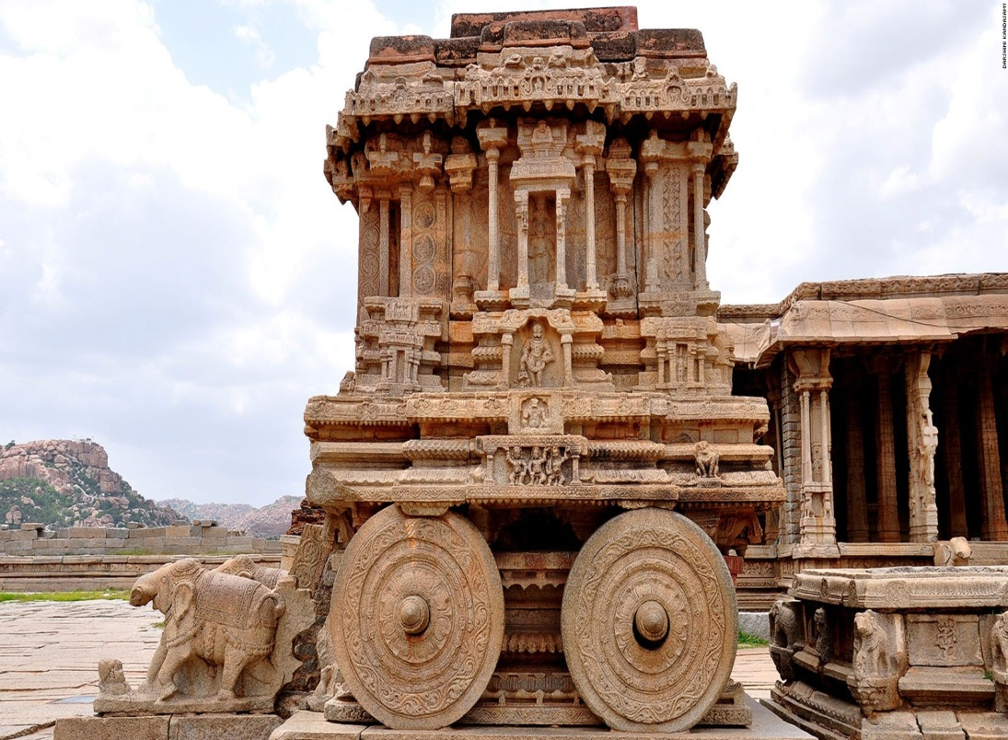
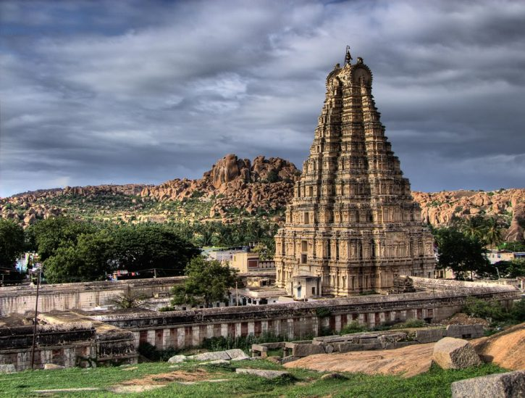

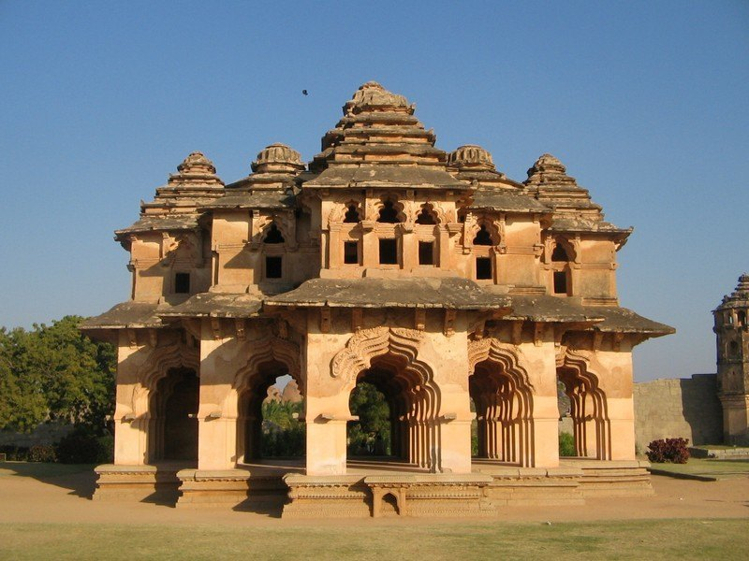

CHAPTER-8
PEASANTS , ZAMINDARS AND THE STATE
ONE MARK QUESTIONS:
- WHAT WAS THE BASIC UNIT OF AGRICULTURAL SOCIETY ?
- WHICH CROPS INTRODUCED INTO INDIA VIA AFRICA AND SPAIN ?
- WHO WAS THE AUTHOR OF AIN-I-AKBARI ?
- WHAT IS JIN-S-KAMIL CROP ?
- WHAT DO YOU UNDERSTAND BY THE TERM KHUD-KASHTA ?
- WHAT WAS THE VILLAGE HEADMAN CALLED ?
- WHY WERE THE FOREST DWELLERS TERMED JANGALI ?
- WHAT IS JAJMANI SYSTEM ?
- WRITE ANY ONE SOURCE OF REVENUE OF VILLAGE PANCHAYATS DURING THE MUGHAL RULE IN INDIA .
- AHOM KINGS BELONGED TO…
- THERE ARE………………DAFTARS (PARTS OF AIN)
- ………………..COINS WERE MORE PREVALENT DURING THE MUGHAL EMPIRE.
- OTTOMON EMPIRE BELONGED TO….
- WHICH TWO TERMS ARE USED FOR PEASANTS IN INDO-PERSIAN SOURCES OF MUGHAL PERIOD ?
- WRITE ANY ONE LIMITATION OF AIN-I-AKBARI.
- AKBAR DIVIDED THE LAND INTO FOUR CATEGORIES ACCORDING TO ITS FERTILITY, NAME THE TYPES OF LAND.
Select the correct option out of the four possible options given after the statement of the questions:
- Name the two classes which were involved in creation of relationship of cooperation, competition and conflict in rural India during Mughal Period.
- Peasants and tenants (b) landlords and patidars (c) peasants and ruling elites (d) Ruiling elites and Mughal rulers
- Which of the following was not a constituent of collective village community during the sixteenth and seventeenth centuries ?
- The cultivators (b) the panchayats (c) the mansabdars (d) the village headmen
- What was the average forest cover in India during the sixteenth and seventeenth centuries ?
- 30 percent (b) 40 percent (c) 50 percent (d) 20 percent
- Match the following:
- Kisan or asami i) owners of the land in their own village
- Khud- Kashta ii) cultivated land on contractual basis
- Pahi- Kashta iii) perfect crops
- Jins-i-Kamil iv) Peasants
- Match the following:
- Tomatoes and potatoes i) Via Africa and Spain
- Maize ii) Bengal
- Sugar iii) Deccan Plateau
- Cotton iv) new world
- Match the following:
- Pirs i) personal lands
- Milkiyat ii) certain services for the state
- Khidmat iii) Fortresses
- Qilachas iv) sufi saints
Complete the following statements with appropriate answers in the blanks.
- Major source for the agrarian history of the sixteenth and the early seventeenth centuries are_______and ______________from the Mughal court.
- One of the most important chronicles was the ____________authored by Akbar’s court historian___________.
- The term used to denote a peasant was __________or Muzarian.
- Crops such as______and__________were jins-i-kamil par excellence.
- In addition to village panchayat each caste or jati in the village had its own_________-.

CHAPTER-9
KINGS AND CHRONICLES – THE MUGHAL COURT
ONE MARK QUESTIONS :
- MUGHALS WERE THE DESCENDENTS OF……
- THE SUCCESSOR OF BABUR WAS………………
- ………………………IS CONSIDERED THE GREATEST MUGHAL EMPEROR.
- MOTHER TONGUE OF THE MUGHALS WAS…………………
- WHO MADE PERSIAN AS THE COURT LANGUAGE OF THE MUGHAL COURT ?
- ASIATIC SOCIETY OF BENGAL WAS ESTABLISHED IN YEAR…………….
- NAME THE FOUR CAPITAL CITIES OF MUGHALS CHRONICALLY.
- WHAT IS NASTALIQ STYLYE OF CALLIGRAPHY ?
- NAME ANY TWO SPECIAL OCCASIONS OF MUGHAL COURT WHEN RAJ MAHAL WAS DECORATED.
- WHAT IS HALO ?
- NAME THE AUTHOR OF BADSHAHNAMA.
- WHAT IS THE MEANING OF SULH-I-KUL ?
- WHAT IS THE MEANING OF THE TERM ‘ HAREM’ ?
- WHO DESIGNED THE ARCHITECTURE OF CHANDNI CHOWK ?
- WHO WAS THE AUTHOR OF HUMAYUN NAMA ?
- IN WHICH YEAR BABUR CAME TO INDIA ?
- BULAND DARWAZA BUILT TO COMMEMORATE WHICH MUGHAL VICTORY ?
- WHICH MUGHAL RULER COMMISSIONED THE CONSTRUCTION OF A WHITE MARBLE TOMB FOR SHAIKH SALIM CHISHTI ?
- WHAT IS CALLIGRAPHY ?
- WHAT IS CHAHAR TASLIM ?
- WHAT WAS KITABKHANA ?
- WHO FOUNDED THE ASIATIC SOCIETY OF BENGAL ?
- WHICH REGION WAS THE MAIN REASON OF CONTENSION BETWEEN MUGHALS AND SAFAVIDS OF IRAN ?
Select the correct option out of the four possible options given after the statement of the question:
- Which one of the following statement is not correct about Mughals ?
- They referred to themselves as descendants of the Turkish ruler Timur on the paternal side
- Babur, the first Mughal ruler, was related to Ghenghiz Khan from his mother’s side
- Babur spoke Turkish and referred derisively to the Mongols as barbaric hordes
- Babur was a descendant of rulers of Ghazni
- Which of the following was the aim of production of chronicles by the Mughals ?
- To project the vision of an enlightened kingdom
- To convey to those who resisted the rule of the Mughals that all resistance was destined to fail
- To ensure that there was an account of their rule for posterity
- All the above
- Which of the following Sanskrit texts were translated into Persian by the Mughal emperors ?
- Ramayana (b) Mahabharata (c) Panchtantra (d) Kadambri
- Match the following:
- Jahangir i) 1658- 1707
- Akbar ii) 1628-58
- Shah Jahan iii) 1605-1627
- Aurangzeb iv) 1556-1605
- a) Badshahnama i) Abul Fazl
- Akbarnama ii) Plato
- Republic iii) Babur
- Tuzk-i-Babri iv) Abdul Hamid Lahori
Complete the following statements with appropriate answers in the blank space’
- Mughal court chronicles were written in___________.
- The centre of manuscript production was known as _________
- ________the art of handwriting, was considered a skill of great importance.
- Edited version of the Akbarnama and Badshahnama were first published by the ________in the nineteenth century.
- Abul Fazl describes the ideal of __________as the corner stone of enlightened rule.
- At Sikri the enormous arched gateway________was meant to remind visitors of the Mughal victory in Gujarat.
- A pupil of Abul Fazl___________-is known as the author of the Badshahnama.
- The emperor began his day at sunrise with personal religious devotion or prayers, and then appeared on a small balcony , the _________facing the east.
- An interesting book giving us a glimpse into the domestic world of the Mughals is the _________written by ___________.
- The officer corps of the Mughals was described as _________held together by loyalty to the emperor.
- The first ruiling group of Indian origin to enter imperial service from 1560 onwards was a Rajput chief_____.
- All holders of government offices held ranks________comprising two numerical designations_________and___________.

CHAPTER-10
COLONIALISM AND THE COUNTRYSIDE
ONE MARK QUESTION:
- WHICH REVENUE SYSTEM WAS INTRODUCED IN BOMBAY DECCAN ?
- BY WHICH NAME WERE THE JOTEDARS CALLED ?
- WHO INTRODUCED THE PERMANENT SETTLEMENT IN BEGAL ?
- WHO WAS THE LEADER OF SANTHAL REBELLION ?
- IN WHICH YEAR DID THE AMERICAN CIVIL WAR BREAK OUT ?
- WHAT WERE THE HILL FOLKS KNOWN FOR ?
- WHAT WAS DAMIN-I-KOH ?
- WHAT WAS THE SUNSET LAW ?
- WHO IS A LATHYAL ?
- WHEN WAS PERMANENT SETTLEMENT INTRODUCED IN BENGAL ?
- WHEN WAS FIFTH REPORT INTRODUCED IN THE BRITISH PARLIAMENT ?
- LIFE OF PAHARIAS OF RAJMAHAL COMPLETELY DEPENDENT UPON……..
- WHO WERE EMERGED AS THE DANGER FOR PAHARIAS ?
- ………………..WAS THE MAJOR SOURCE OF COTTON FOR BRITISH TILL 1862.
- WHY WERE THE ESTATES OF THE ZAMINDARS AUCTIONED IN THE COLONIAL BENGAL ? ( ANY ONE REASON)
- WHICH REVENUE SYSTEM WAS INTRODUCED BY THE BRITISH GOVERNMENT IN BOMBAY DECCAN ?
- WHO WAS FRANCIS BUCHANAN ?
- WHAT IS LIMITATION LAW OF 1859 ?
Select the correct option out of the four possible options given after the statement of the question:
- Name the first state which came under the rule of British.
- Bengal (b) Punjab (c) Hyderabad (d) Mysore
- How did British establish colonial rule in Bengal ?
- By sending in British army in the state
- By entering into treaty with the rulers of the Bengal
- By introducing doctrine of lapse
- By introducing a new revenue system
- What problems did British face in Bengal in 1770s ?
- Recurrent famines
- Revolt by the inmates of Bengal
- Bengal rulers tried to enter into treaty with the rulers of other state
- Revolt by the servants of East India company.
- Besides fictitious auctions, which of the following ways by which zamindars circumvented displacement ?
- When people from outside the zamindari, bought an estate, their agents would be attacked by lathyals of the former zamindar
- Sometimes even ryots resisted the entry of the outsiders
- Ryots remained loyal to the zamindars as the sale of zamindari disturbed their sense of identity and their pride
- All the above
- Match the following:
- Raja of Burdwan i) Jotedars
- Rich peasants ii) Mandals
- Village headmen iii) subjects
- Proja iv) Auction of estates in 1793
- Match the following:
- Benami i) Rajmahal hills
- Fifth Report ii) anonymous
- Buchanan iii) To enquire into the affairs of the company
- Paharias iv) Surveys of the areas under the jurisdiction of East India company
Complete the following statements with appropriate answer in the blank space
- According to Recordian ideas a landowner should have a claim only to the __________that prevailed at a given time.
- The revenue system that was introduced in the Bombay Deccan, came to be known as the ___________.
- In 1859, the British passed a __________law that stated that the loan bonds signed between moneylenders and ryots would have validity for only________years.
- The report of the __________was presented to the British Parliament in _____________.

CHAPTER-11
REBELS AND THE RAJ- THE REVOLT OF 1857 AND ITS REPRESENTATIONS
ONE MARK QUESTIONS:
- FROM WHERE DID THE REVOLT OF 1857 START ?
- WHO WAS FORCED TO LEAD THE REVOLT OF 1857 ?
- WHO LED THE REVOLT AT KANPUR ?
- WAJID ALI SHAH WAS THE NAWAB OF …………
- BIJRIS QADR WAS THE YOUNG SON OF…..
- AWADH WAS ANNEXED INTO THE BRITISH EMPIRE IN………………
- AWADH AND SATARA WERE CAPTURED UNDER……………………..
- NAME THE IMMEDIATE CAUSE FOR THE MUTINY OF 1857.
- WHO LED THE REVOLT OF 1857 IN JHANSI ?
- GIVE ANY ONE POLITICAL REASON FOR THE REVOLT OF 1857.
- GIVE ANY ONE SOCIAL REASON FOR THE REVOLT OF 1857.
- GIVE ANY ONE MILITARY CAUSE FOR THE REVOLT OF 1857.
- WHICH WAR IS KNOWN AS THE FIRST WAR OF INDEPENDENCE IN THE INDIAN HISTORY ?
- GIVE ANY ONE REASON FOR THE FAILURE OF 1857 REVOLT.
- WHEN AND BY WHOM WAS THE SUBSIDIARY ALLIANCE DEVISED ?
- NAME THE POET OF “ KHOOB LADI MARDANI WO TO JHANSI WALI RANI THI”.
- WHAT DO YOU UNDERSTAND BY THE TERM ‘ FIRANGI’ ?
- WHO LED THE REVOLT OF 1857 IN BIHAR ?
- WHO WAS CALLED AS ‘ DANKA SHAH’ ?
- “ RUMOURS PLAYED A PART IN MOVING PEOPLE TO ACTION BEFORE THE REVOLT OF 1857. WRITE ANY ONE RUMOUR IN THIS REGARD.
- NAME THE PAINTER OF THE BRITISH PAINTING “ RELIEF OF LUCKNOW”.
- NAME THE PAINTER OF THE BRITISH PAINTING “ IN MEMORIUM”.
Select the correct option out of the four possible opinions after the statement of the questions:
- Which one of the following marked the beginning of mutiny by Sepoys in 1857 ?
- Firing of the evening gun
- Sounding of the bugle
- Seized the bell of arms and plundered the treasury
- Attacked government buildings the jail, treasury, telegraph office and bunglows
- Which of the following images was to commemorate the British heroes who saved the English and repressed the rebels ?
- Relief of Lucknow by Thomas Jones Barker in 1859
- In memoriam
- Miss Wheeler
- None of the above
- Which of the following paintings showed the English women, and children huddled in a circle looking helpless and innocent seeming waiting for the inevitable ?
- In Memorium (b) relief of Lucknow (c) Miss Wheeler (d) None of the above
- Match the following:
- 11 May 1857 i) Kunwar Singh
- Kanpur ii) Rani Laxmi Bai
- Jhansi iii) Nana Sahib
- Arrah in Bihar iv) Holy month of Ramzan
- Match the following:
- Mutiny i) Firangi raj
- Revolt ii) A collective disobedience of rules and regulations within the armed force
- British rule iii) Arzi
- Petition iv) A rebellion of people against established authority and power
Complete the following statements with appropriate answer in the blank space.
- In the months of May and June of 1857 __________rule collapsed like a house of cards.
- There was a rumour that the British rule would come to an end on the centenary of the batlle of Plassey on ______________
- In____________Governor General_________described the kingdom of __________________as a ‘ cherry that will drop in our mouth one day’.
- Nawab ________was dethroned and exiled to ___________on the plea that the region was being misgoverned.
- The British introduced ____________in 1856 in Oudh.
- Awadh was, infact called the ‘ nuersery of _______.
- Identify the image.
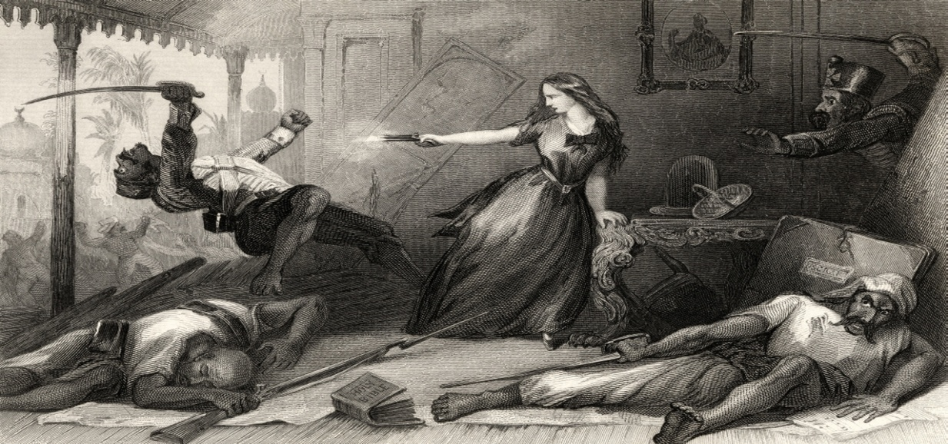

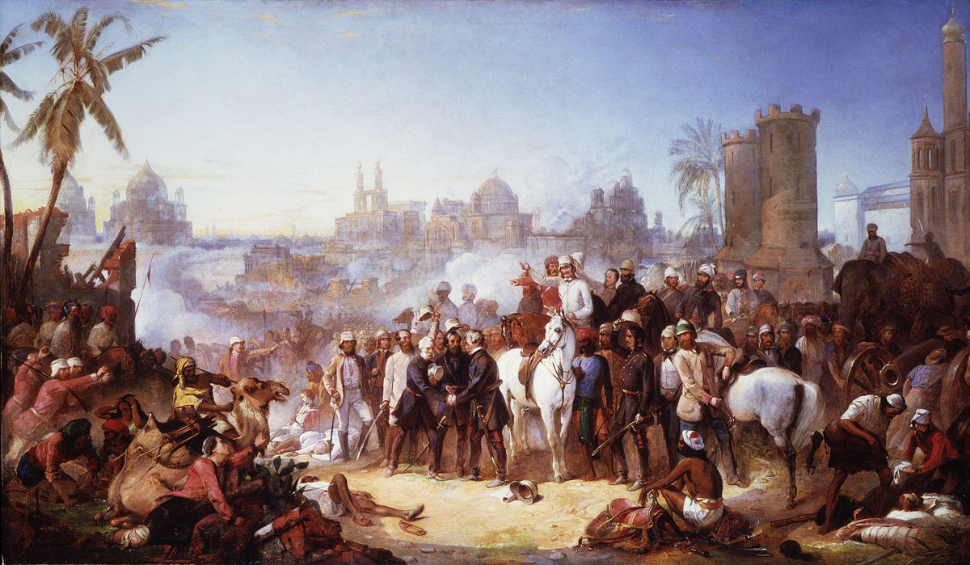
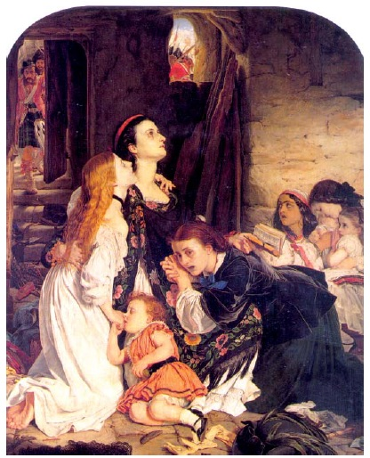

CHAPTER 12
COLONIAL CITIES AND THE COUNTRYSIDE
ONE MARK QUESTIONS:
- WHAT WAS THE IMPORTANCE OF DELHI, AGRA AND LAHORE DURING THE MUGHAL PERIOD ?
- WHEN DID EAST INDIA COMPANY SETTLE IN MADRAS ?
- WHEN DID EAST INDIA COMPANY SETTLE IN CALCUTTA ?
- WHEN DID ALL INDIA CENSUS BECOME A REGULAR FEATURE ?
- WHICH VICEROY OFFICIALLY MOVED HIS COUNCIL TO SHIMLA ?
- WHAT DO YOU UNDERSTAND BY THE TERM ‘ DUBASHES’?
- WHO DONATED MONEY FOR THE CONSTRUCTION OF UNIVERSITY HALL ?
- WHY WERE HILL STATIONS IMPORTANT FOR THE COLONIAL ECONOMY ?
- HOW DID EAST INDIA COMPANY GOT BOMBAY ?
- MADRAS AMONG THE BRITISH POPULATION WAS KNOWN FOR …………..
- CIVIL LINES WERE ESTABLISHED FOR THE ………..
- LOTTERY COMMITTEE WAS ESTABLISHED IN………
- AMERICAN CIVIL WAR WAS STARTED IN………………
- GATEWAY OF INDIA WAS FORMED TO WELCOME………………..
- WHAT WAS THE OBJECTIVE OF DEVELOPING INSTITUTIONS LIKE MUNICIPAL CORPORATIONS IN TE 19TH CENTURY ?
- NAME ANY TWO ARTICHECTURAL STYLE USED IN BRITISH BOMBAY FOR MAKING BUILDINDS .
- WRITE EXAMPLE OF ANY ONE BUILDING OF BOMBAY CONSTRUCTED USING INDO –SARACENIC,
NEO- GOTHIC AND NEO – CLASSICAL ARCHITECTURAL STYLE.
Select the correct option out of the four possible options given after the statement of the question.
- Which of the following groups of three cities each were originally fishing and weaving villages?
- Madras, Calcutta and Bombay
- Madras , Calcutta and Calicut
- Madras, Delhi and Calcutta
- Calcutta, Madras and Surat
- Which of the following features was not of towns or rural areas before the British rule ?
- In the countryside people subsisted the cultivating land ,forging in the forest or rearing animals.
- Towns were peopled with artisans, traders, administrators and rulers
- Towns dominated over the rural population , thriving on the surplus and taxes derived from agriculture
- Rural areas were often fortified by walls which symbolized their separation from the towns.
- Why did the towns become famous during the Mughal times ?
- For concentration of populations
- For monumental building
- Their imperial grandeur and wealth
- All of the above
- What methods were employed by the British to monitor the growth of cities during their rule ?
- To carry out regular survey
- To gather statistical data
- To publish various official reports
- All of the above
- Why were the British keen on mapping ? Which of the following were their objects ?
- To understand the landscape and know the topography
- To plan the development of the towns
- To develop commerce and consolidate power
- To get information regarding locations of hills, rivers and vegetation and planning structures for defence purposes
- Name the features which did not belong to Gothic style of architecture.
- High pitched roofs (b) Pointed arches (c) lofty pillars (d) Detailed decoration
- Match the following
- Madras i) 1690
- Calcutta ii) 1661
- Bombay iii) 1639
- First census iv) 1881
- Match the following:
- Europeans i) Woolen and cotton textiles
- Indians ii) Steel
- Kanpur iii) Black town
- Jamshedpur iv) White town
- Match the following:
- Chintadripet i) Built around the temple
- Washermanpet ii) Christian Boatmen
- Royapuram iii) Colony of dyers and bleachers
- Living quarters iv) weavers
Complete the following statements with appropriate answer in the blank space
- The Mughal treasury was located in the ____________
- The railway were introduced in India in __________.
- It became a practice for viceroys to move to ___________during the summer months.
- Simla became the official residence of the ___________of the Indian army.
- In Madras_____________became the nucleus of the White town where most of the Europeans lived.

CHAPTER-13
MAHATMA GANDHI AND THE NATIONAL MOVEMENT
ONE MARK QUESTIONS:
- WHERE DID GANDHI USED SATYAGRAHA FOR THE FIRST TIME ?
- ……………….WAS THE MODERATE LEADER OF CONGRESS.
- GANDHIJI TOOK BACK NON- COOPERATION MOVEMENT IN ……………….
- PEASANT SATYAGRAHA AT BARDOLI WAS HOLD IN……………………
- …………………WAS THE CONGRESS PRESIDENT AT THE LAHORE SESSION.
- DANDI MARCH BROUGHT FORWARD……….
- DISTINGUISH BETWEEN THE POLICIES OF ASSERTIVE AND MODERATES NATIONALISTS.
- AT WHICH THREE PLACES GANDHIJI INITIATED HIS SATYAGRAHA AFTER HIS RETURN FROMSOUTH AFRICA ?
- WHEN AND WHERE WAS THE POLICY OF NON- COOPERATION APPROVED ?
- WHEN AND WHERE WAS ‘ POORNA SWARAJ’ FORMALLY PROCLAIMED ?
- WHY DID GANDHIJI CALL OFF THE NON- COOPERATION MOVEMENT ?
- WHEN DID THE SIMON COMMISSION COME TO INDIA ?
- WHEN AND WHERE WAS THE SECOND ROUND TABLE CONFERENCE HELD ?
- WHEN DID THE CRIPPS MISSION VISIT INDIA ?
- BY WHICH FAMOUS INCIDENT THE CIVIL DISOBEDIENCE MOVEMENT START ?
- NAME ANY ONE BOOK WROTE BY MAHATMA GANDHI.
- WHO GAVE THE SLOGAN ‘ DO OR DIE’ ?
- WHO WERE LAL-BAL-PAL ?
- WHO WAS INVOKED AS THE ‘ FATHER OF NATION’ ?
- WHAT WAS THE DIRECT ACTION DAY ?
- WHERE DID GANDHI’S ASHRAM LOCATED ?
- IN WHICH YEAR THE MUSLIM LEAGUE PASS A RESOLUTION FOR A SEPARATE NATION- PAKISTAN.
- WHO CALLED FOR THE ‘ DIRECT ACTION DAY’ HARTAL ?
- WHO LED THE KHILAFAT MOVEMENT IN INDIA ?
- IN WHICH YEAR MAHATMA GANDHI GIVE A CALL FOR THE QUIT INDIA MOVEMENT ?
- WHEN DID , MAHATMA GANDHI MAKE HIS MAJOR PUBLIC APPEARANCE ?
- WHO WROTE THE BOOK “ THE FINEST HOUR” ?
Select the correct option out of the four possible options given after the statement of the question:
- How did Historian Chandran Devanesan relate South Africa to Gandhi ?
- South Africa was ‘the making of the Mahatama’
- South Africa was the testing laboratory for the Mahatma
- South Africa was the examination for the Mahatama
- None of the above
- By 1922 Gandhiji had transformed Indian Nationalism. Which of the following category of people started taking part in it ?
- Peasants (b) Workers (c) Artisans (d) professionals and intellectuals
- By, 1922 which one of the following were the reasons for the popularity of Gandhiji among the people ?
- He dressed like them in dhoti and loin cloth
- He lived like them
- He spoke their language
- He emphathised and even identified with them
- Why did Gandhi make tax on salt as the major issue for mobilizing people during Civil Disobedience Movement ?
- Salt was consumed by an average Indian
- It was a major source of employment in village industry
- It was a reflection of the imperialist rule of the British
- It implied destruction of property that nature produces in abundance
- Match the following:
- Kheda i) Jallianwala Bagh
- Champaran ii) Textile mill workers
- Ahmedabad iii) remission of taxes due to failure of crops
- Amritsar iv) Indigo planters
- Match the following:
- Louis Fischer i) Industrialist
- G.N.Broomfield ii) A close associate of Gandhiji
- G.D. Birla iii)The judge who presided over Gandhi’s trial in 1922
- Mahadev Desai iv) Gandhi’s American biographer
- Match the following:
- December 1929 i) Independence Day
- 26 January 1930 ii) Beginning of Dandi march
- 12 March 1930 iii) Gandhi Irwin pact
- 5th March iv) Congress session at Lahore
Complete the following statements with appropriate answer in the blank space.
- Bal Ganga Dhar Tilak, Lala Lajpat Rai and Bipin Chandra Pal were the leaders of ___________movement.
- On________advice, Gandhiji spent a year travelling around British India getting to know the land and its people.
- Gandhi ji’s first major public appearance was at the opening of the _________in_________.
- On ________in Jallianwala Bagh_______ordered his troops to open fire on a nationalist meeting.
- Khilafat movement aimed at restoration of __________.
- After the failure of ________________.Gandhi decided to launch ___________movement on _______August __________.
- In________________the Muslim League passed a resolution demanding a measure of autonomy for the Muslim majority areas of the sub-continent.
- Write in sequence.
- First round table conference in London
- World war II begins
- Swadeshi Movement
- Return of Gandhiji From South Africa
- Opening of B.H.U
- Write in sequence.
- Gandhiji was shot dead by Nathu Ram Godse
- Wavell was replaced as viceroy by lord Mountbatten
- Direct Action Day to press the league’s demand for Pakistan
- Cripps Mission
- Second world war begins

CHAPTER – 14
UNDERSTANDING PARTITION
ONE MARK QUESTIONS :
- WHEN WAS HINDU MAHASABHA FOUNDED ?
- WHEN WERE SEPARATE ELECTORATES GRANTED TO THE MUSLIMS BY THE COLONIAL RULERS ?
- WHEN WAS THE LUCKNOW PACT SIGNED ?
- IN WHICH YEAR ELECTIONS TO THE PROVINCIAL LEGISLATURES WERE HELD FOR THE FIRST TIME ?
- WHO IS THE WRITER OF THE SONG ‘ SARE JAHAN SE ACHHA HINDUSTAN HUMARA ‘ ?
- ON WHICH DAY MUSLIM LEAGUE ANNOUNCED, ‘ DIRECT ACTION DAY’.
- DURING THE PARTITION OF INDIA , HOW DID THE SURVIVORS DESCRIBE THE EVENTS OF 1947 ?
- WHAT IS THE MEANING OF ‘ HOLOCAUST’ ?
- MUSLIM LEAGUE WAS ESTABLISHED IN….
- WHO WAS KNOWN AS FRONTIER GANDHI ?
- BANGLADESH WAS ESTABLISHED IN……………
- WHEN WAS THE CABINET MISSION SENT TO INDIA ?
- WRITE ONE SIGNIFICANCE OF THE ORAL SOURCES OF HISTORY .
- GIVE ANY ONE REASON FOR THE PARTITION OF INDIA ?
- WRITE ANY ONE FEATURE OF MARLEY MINTO ACT OF 1909.
- WHEN DID THE GOVERNMENT OF INDIA ACT WAS PASSED ?
- WHAT IS COMMUNAL POLITICS ?
- NAME THE INDIAN PARLIAMENT BEFORE INDEPENDENCE 1947.
- WHAT WAS THE TWO NATION THEORY OF JINNAH ?
Select the correct option out of the four possible options given after the statement of the question.
- What are the terms associated with partition of India ?
- Maashal lal (martial law)
- Mara mari (killings)
- Raula or hullar (disturbance,tumult,uproar)
- All above
- What are the stereotypes attached with Muslims by other communities ?
- Muslims are cruel and bigoted
- They are unclean
- They are descendants of invaders
- All the above
- What are the ideas about the Hindus which are true out of the following ?
- Hindus are kind
- They are liberal
- They are pure
- All the above
- Match the following
- 1909 i) Shuddhi
- 1930s ii) separate electorates
- Arya Samaj iii) elections to the provincial legislatures
- 1937 iv) music before mosque
- Match the following.
- Muslim League i) Bengali Hindus
- Hindu Mahasabha ii) Founded in1875
- Arya Samaj iii) Founded in 1915
- Bhadralok iv) Founded in 1906 in Dhaka
Complete the following statements with appropriate answer in the blank space
- Speaking of the killings, rape, arson and loot that constituted partition, contemporary observers and scholars have compared with ______of Germany.
- In the early 1930s Arya Samaj began a _______movement, which aimed at bringing back those Hindus who had embraced___________religion.
- The provincial elections of 1946 only entitled ________percent of the population, the right to vote and a mere one percent in the elections for the Central Assembly.

CHAPTER -15
FRAMING THE CONSTITUTION
ONE MARK QUESTIONS:
- INDIAN CONSTITUTION COME INTO FORCE ON---
- WHEN WAS THE ROUGH SKETCH OF THE CONSTITUTION PASSED BY THE CONSTITUENT ASSEMBLY ?
- HOW MANY SESSIONS OF THE CONSTITUENT ASSEMBLY WERE HELD ?
- WHO WAS THE PRESIDENT OF THE CONSTITUENT ASSEMBLY ?
- MAHATMA GANDHI WANTED TO MAKE …………LANGUAGE AS THE NATIONAL LANGUAGE.
- WHO WAS THE CHAIRMAN OF DRAFTING COMMITTEE ?
- NAME ANY THREE LEADERS WHO PLAYED AN IMPORTANT ROLE IN THE CONSTITUENT ASSEMBLY.
- WHO PRESENTED THE OBJECTIVES RESOLUTION IN THE CONSTITUENT ASSEMBLY AND WHEN ?
- WHAT DID THE CONSTITUENT ASSEMBLY RECOMMEND TO RESOLVE THE PROBLEMS OF THE UNTOUCHABLES ?
- WHO RPOPOSED THAT THE NATIONAL FLAG OF INDIA BE A ‘ HORIZONTAL TRICOLOUR OF SAFFRON, WHITE AND DARK GREEN IN EQUAL PROPORTION’, WITH A WHEEL IN NAVY BLUE AT THE CENTRE ?
- WHO MADE A POWERFUL PLEA FOR CONTINUING SEPARATE ELECTORATES ?
- WHO MADE AN AGGRESSIVE PLEA THAT HINDI BE USED AS THE LANGUAGE OF CONSTITUTION MAKING ?
Select the correct option out of the four possible options given after the statement of the question.
- How many members of the Constituent Assembly were also members of the Congress ?
- 82% (b) 92 % (c) 72% (d) 62%
- How the decision taken at the Constituent Assembly were democratic ?
- The arguments were reported in the newspapers
- The proposals were publicly debated
- Criticisms and counter-criticisms in the press in the turn shaped the nature of the consensus that was ultimately reached on specific issues
- The public was also asked to send in their views on what needed to be done.
- Name the leaders of the Constituent Assembly .
- Jawahar Lal Nehru (b) Vallbah Bhai Patel (c) Rajendra Prasad (d) Moti Lal Nehru
- Match the following
- 26 Jan 1950 (i)India become independent
- 15 August 1947 ii) First meeting of the Constituent Assembly began
- 9th December 1946 iii) Constitution came in to force
- 13 December 1946 iv) Introduction of objective resolution by Nehru in assembly
- Match the following
- Jawahar Lal Nehru (i) President of the constituent assembly
- Vallabh Bhai Patel ii) Objectives Resolution
- Rajendra Prasad reports iii) Key role in drafting of several and working to reconcile
Opposing points of views
- B.R.Ambedkar iv) Role as chairman of drafting Committee
Fill in the blanks:
- With B.R. Ambedkar , (chairman of the drafting committee) there were two other lawyers______________from Gujarat and _________from Madras, both of whom gave crucial inputs in the drafting of the constitution.
- In 1935, electorate remained limited to no more than ___________to percent of the adult population.
- B. Pocker Bahadur from ______made a powerful plea for continuing__________.
- The draft constitution provided for three lists of subjects ____________,_______________and___________.

